HW 5

Kip Taylor

1. Answer below
2. Cost of C->B : 6, C->D : 3, C->E : 5 , thus the vectors coming from B,D,E are :

B: (5, 0, 8, 12, 6, 2)

D: (16, 12, 6, 0, 9, 10)

E: (7, 6, 3, 9, 0, 4)

Table is :

|  |  |  |  |
| --- | --- | --- | --- |
|  | B | D | E |
| A | **5+6 = 11** | 16+3=19 | 7+5=12 |
| B | **0+6=6** | 12+3=15 | 6+5=11 |
| C | 8+6= 14 | 6+3=9 | 3+5=8 |
| D | 12+6=18 | **0+3=3** | 9+5=14 |
| E | 6+6=12 | 9+3=12 | **0+5=5** |
| F | **2+6=8** | 10+3=13 | 4+5=9 |

**New routing table : C(11,6,0,3,5,8)**

**Outgoing lines :** **(B,B,-,D,E,B) as they were minimum from each neighboring vectors**.

1. Diagram then explanation :

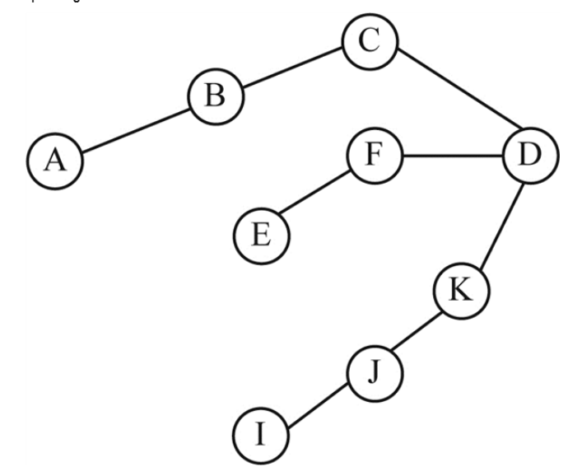

1. **How the messeges are sent :**
2. **C sends to b and d**
3. **D sends to f , k**
4. **F forwards to e**
5. **K forwards to j**
6. **And j forwards to I**
7. Calculations below :
8. Calculate data , 48 bytes = 48x8 ( bits) = 348 bits

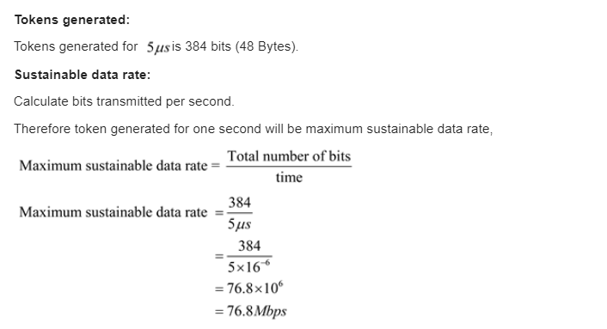

1. **Thus max sustainable data rate = 76.8 Mbps**
2. Calc below :
3. **Time = t**
4. **Computer can transmit at the full 6 Mbps**
5. **6t = 8 + t**
6. **Therefore t = 1.6 seconds**
7. **Due to sheer scope below are just the answers as my work literally is 8 pages.**
8. **Starting address : 198.16.0.0 , last address : 198.16.15.255 mask: 198.16.0.0/20**
9. **Starting address : 198.16.16.0, last address: 198.16.23.255, mask: 198.16.16.0/21**
10. **Starting address: 198.16.32.0, last address: 198.16.47.255, mask: 198.16.32.0/20**
11. **Starting address: 198.16.64.0, Last address: 198.16.95.255, Mask: 198.16.64.0/19**